CARA COMPILE DAN RUNNING PROJECT

1. Sediakan Aplikasi Eclips, Xampp, Postman dan SQLyog.

 

1. **Start MySQL** pada Xampp

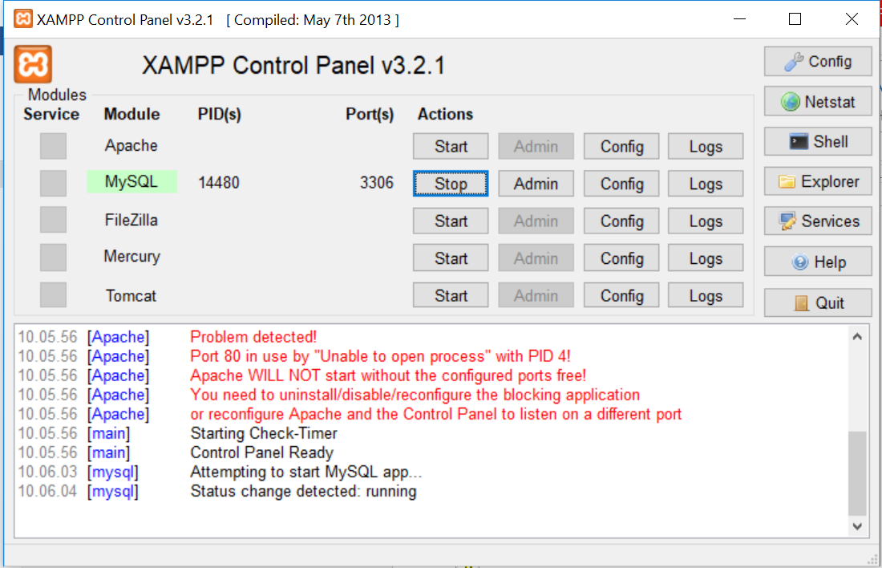

1. Buka eclips, lalu pilih workspace. Kali ini, buka File ProjectTestTelkom.

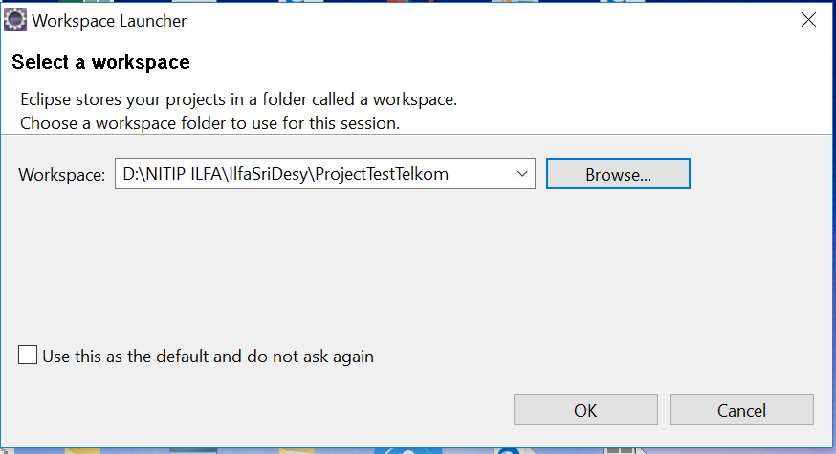

1. Tidak lupa, restore database book_db pada SQLyog

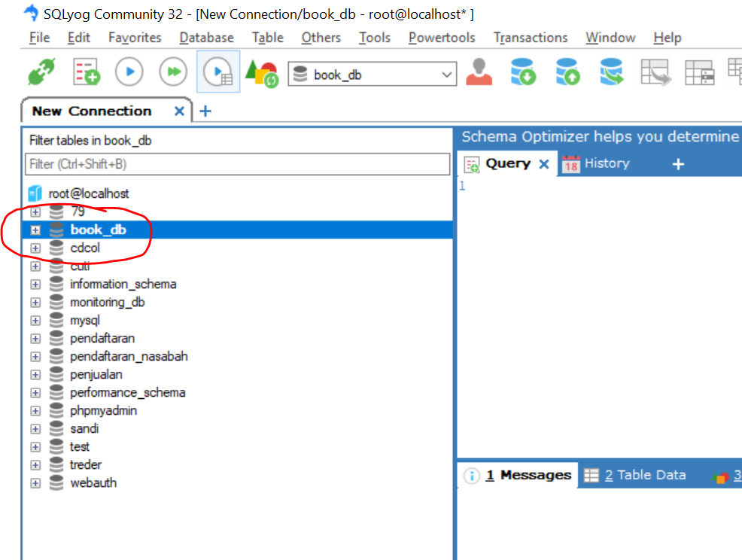

1. Kembali ke eclips, lakukan Maven Build. Klik kanan project **springbootrestapiilfasridesy -> Run AS -> Maven Build**

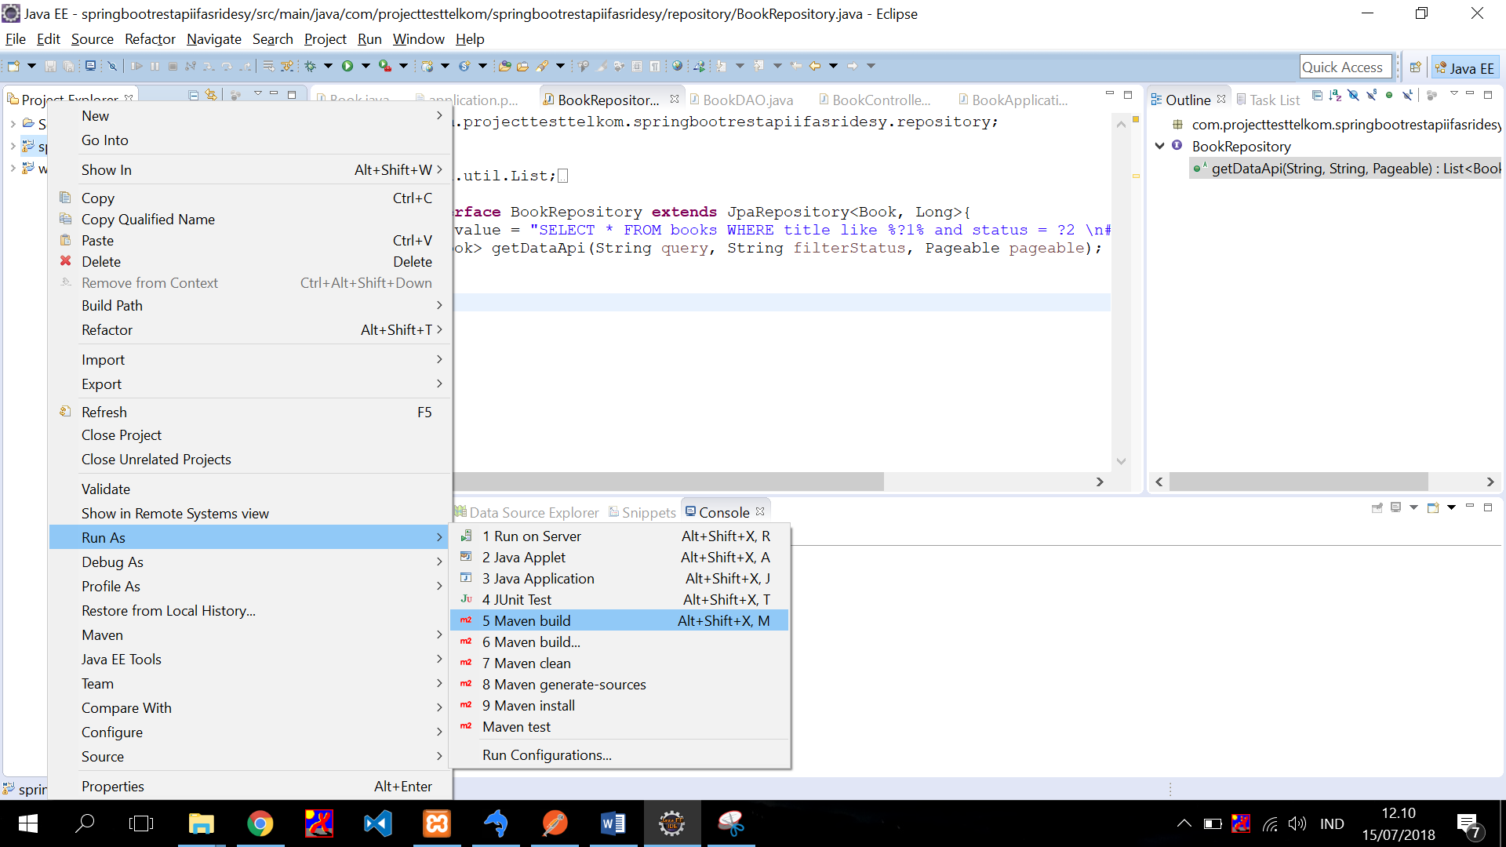

1. Lakukan clean project terlebih dahulu, yaitu dengan:

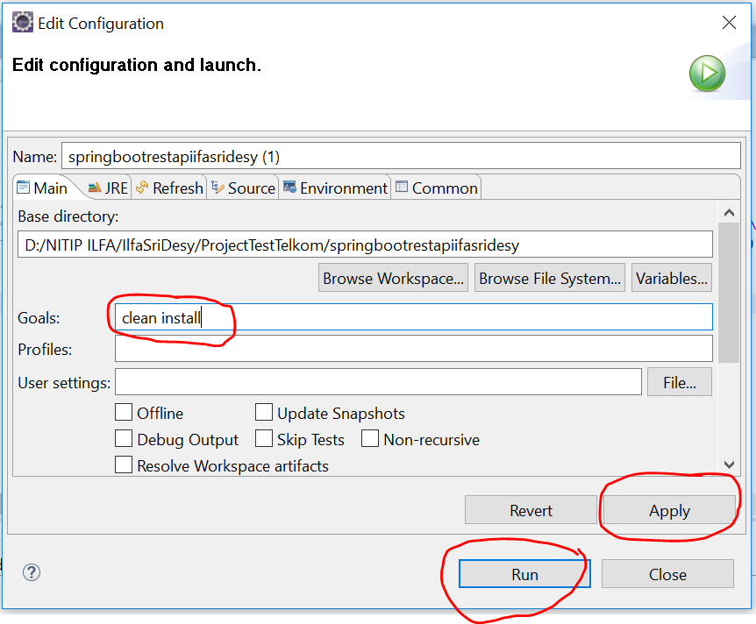

Ketik **clean install -> Apply -> Run.**

1. Tunggu proses build pada tab console, hingga BUILD SUCCESS

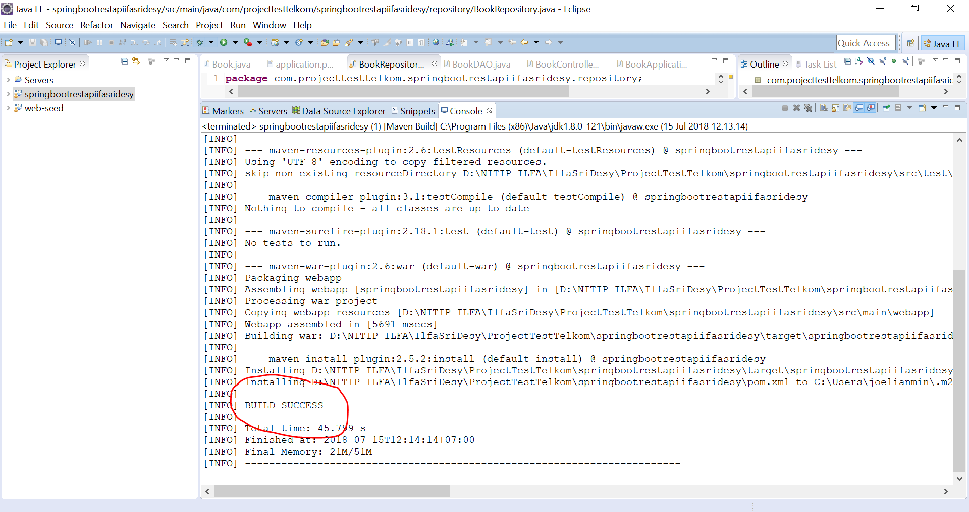

1. Pastikan Server sudah dipilih, yaitu menggunakan **apache-tomcat-8.0.32.**
2. Pilih **project springbootrestapiilfasridesy -> Java Resource -> src/main/java -> com.projecttesttelkom.springbootrestapiilfasridesy -> BookAplication.java**

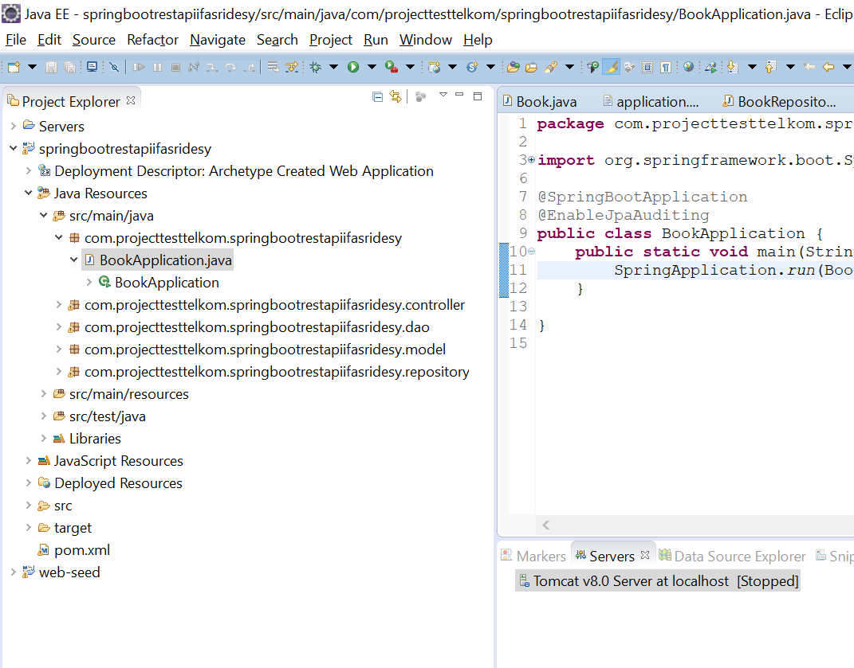

1. Klik kanan **BookAplication.java -> Run As -> Java Application**.

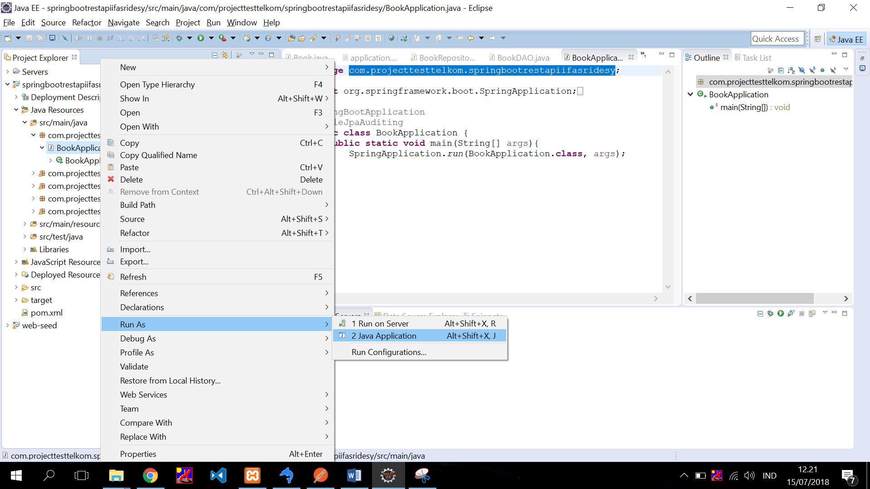

1. Tunggu hingga proses running selesai.

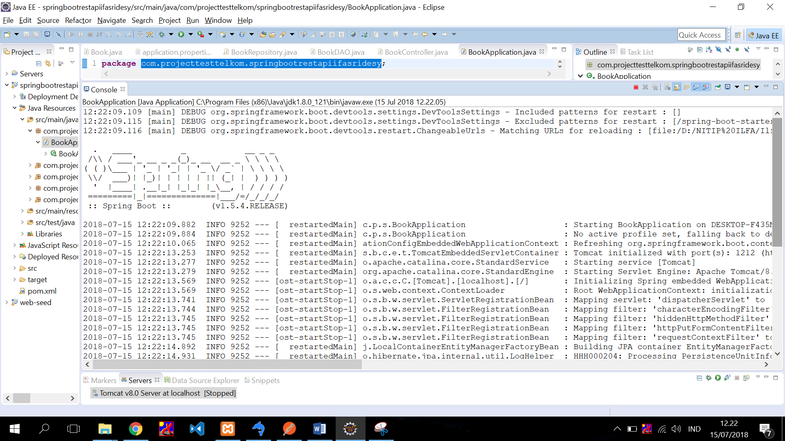

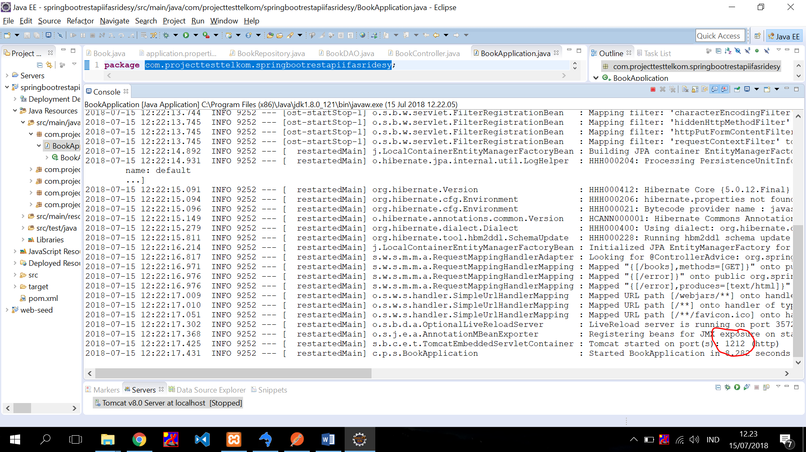

1. Perhatikan port yang berada di gambar no 11. Port tersebut digunakan untuk test project di Postman.
2. Buka Postman. Lalu masukan API sebagai berikut: (Contoh-contoh API bisa di lihat pada file evidence project test telkom.xlsx)

http://localhost:1212//books?page[number]=1&page[size]=10&sort=id&query=&filter[status]=active

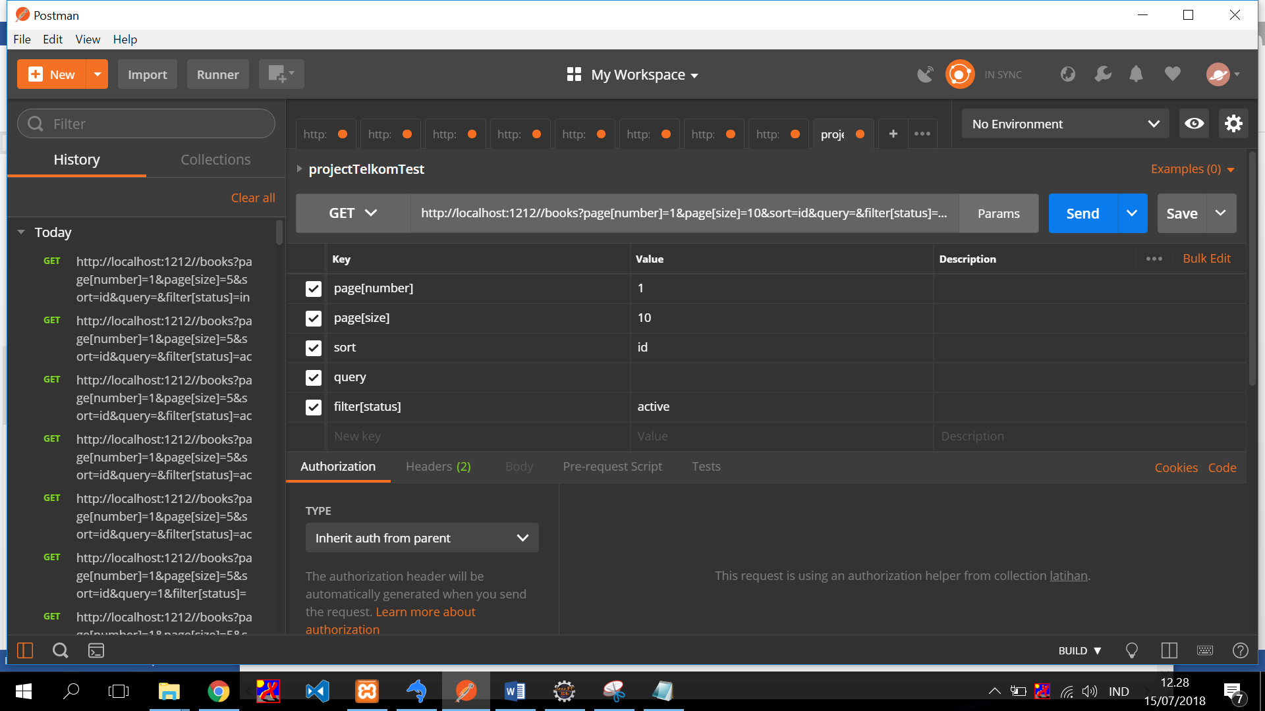

1. Klik **Send.**
2. Maka response akan muncul berupa JSON.

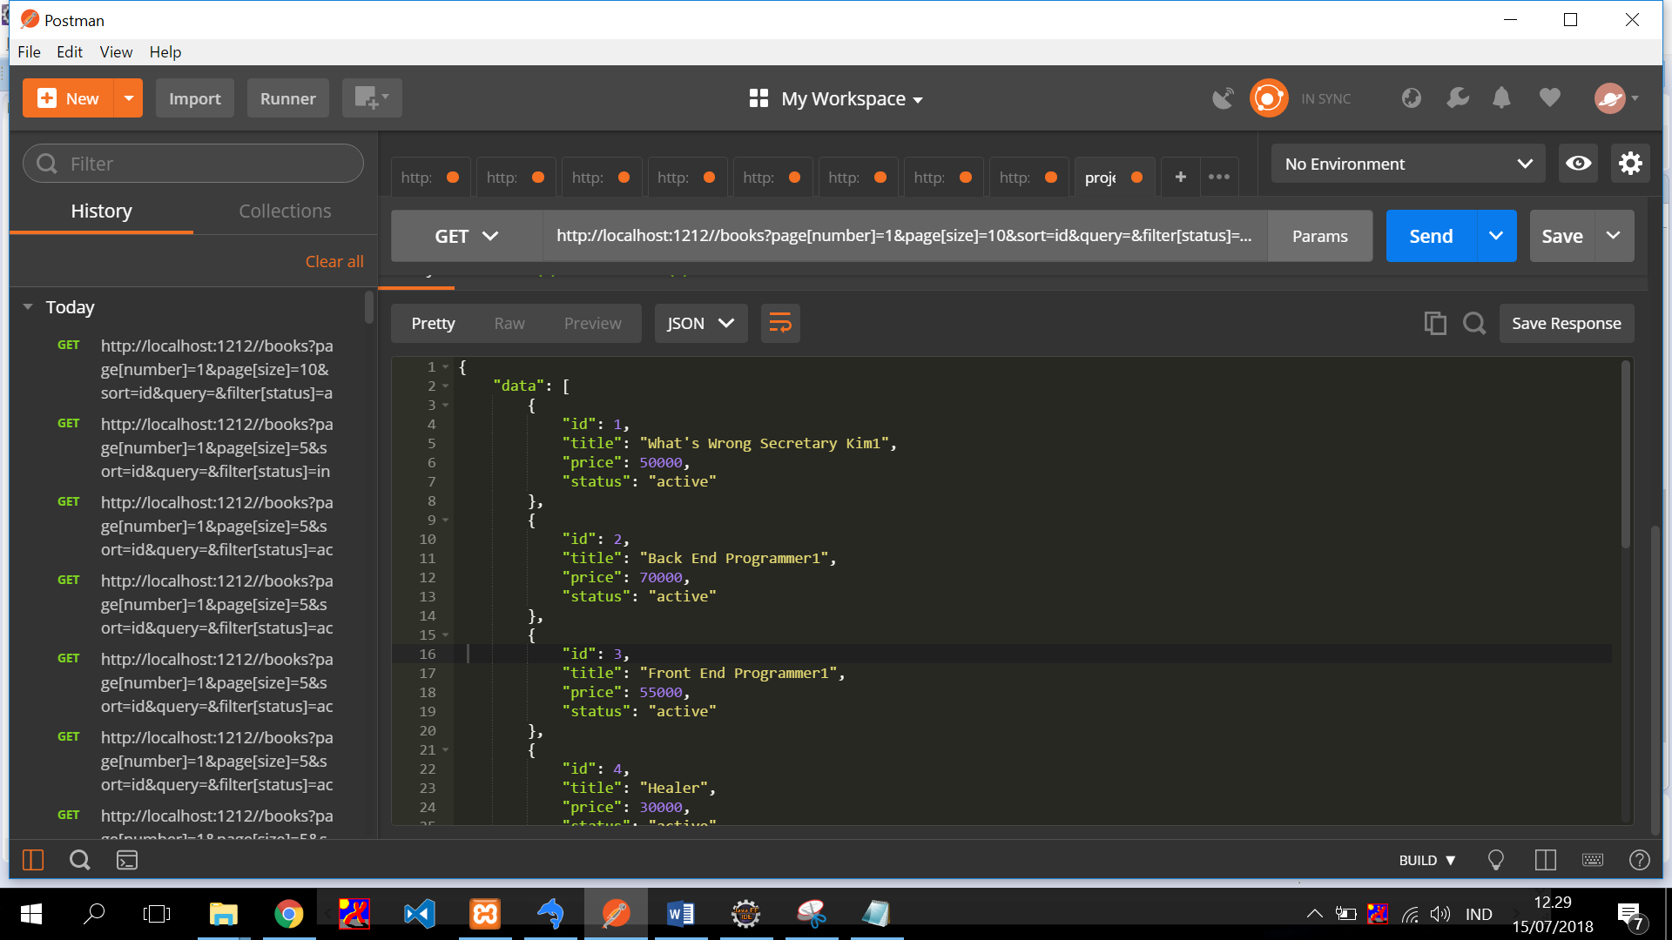

{

"data": [

{

"id": 1,

"title": "What's Wrong Secretary Kim1",

"price": 50000,

"status": "active"

},

{

"id": 2,

"title": "Back End Programmer1",

"price": 70000,

"status": "active"

},

{

"id": 3,

"title": "Front End Programmer1",

"price": 55000,

"status": "active"

},

{

"id": 4,

"title": "Healer",

"price": 30000,

"status": "active"

},

{

"id": 5,

"title": "Stand By Me",

"price": 20000,

"status": "active"

},

{

"id": 6,

"title": "How To Program",

"price": 100000,

"status": "active"

},

{

"id": 7,

"title": "Teka Teki Silang",

"price": 5000,

"status": "active"

}

],

"meta": {

"totalData": 7,

"size": "10",

"count": 7,

"totalPages": 1,

"page": "1"

},

"status": {

"headers": {},

"body": null,

"statusCode": "OK",

"statusCodeValue": 200

}

}

1. **Sekian dan Terimakasih**